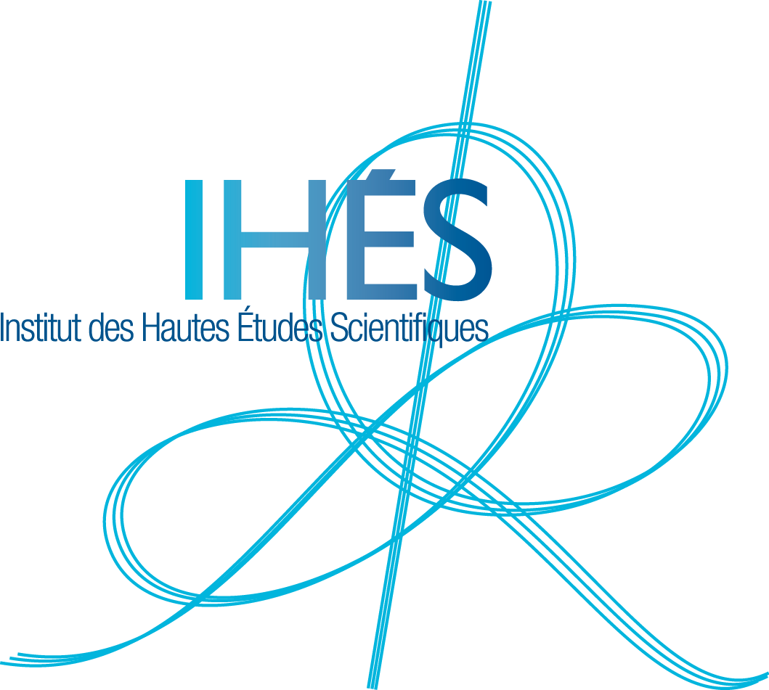
Press release – April 27th, 2015

Crucial theoretical breakthrough
to detect gravitational waves

Combining an analytical approach with numerical methods, an international team of physicists has obtained an accurate theoretical description of the gravitational waves emitted during the last orbits of a binary system made of two neutron stars. This new result could have a significant astronomical impact in allowing the detectors LIGO and Virgo to observe these waves in the next few years.

Gravitational waves : a key prediction of Einstein’s Theory of General Relativity
In 1915, Albert Einstein completed his theory of General Relativity, within which Space is similar to an elastic medium deformed by matter. The following year, he
showed that this deformation propagates at the speed of light, in the form of waves, called « gravitational waves ». A system made of two neutron stars, orbiting around each other, generates gravitational waves.

Undetected waves so far
The gravitational waves emitted, more than 600 millions of light years away, by a system of two
neutron stars arrive on Earth with such a small amplitude (10⁻²²) that it is of paramount importance to have at hand a very precise theoretical model of their shape to be able to extract them out of the detector’s noise. Now that the ground-based interferometers LIGO (USA) and Virgo (French-Italian) are coming back online at an improved sensitivity, such a theoretical advance may allow one to finally detect the gravitational waves emitted during the coalescence of a system of two neutron stars.

A team of European scientists with complementary skills
Sebastiano Bernuzzi (CalTech, Parma University) and Tim Dietrich (Jena University) are two young experts in numerically solving Einstein’s equations by means of supercomputers. Thibault Damour et Alessandro Nagar (Institut des Hautes Études Scientifiques) have developed an analytical description (called Effective One Body method) of the orbital motion and of the gravitational wave emission of binary systems made of dead stars (black holes or neutron stars). By comparing state of the art numerical simulations of coalescing neutron stars binaries to their best available analytic representations, the team has succeeded in reliably describing the gravitational wave signal up to the moment when the two neutron stars become so close that they merge together. This result just appeared in the prestigious journal Physical Review Letters (PRL 114, 161103, 23 avril 2015).

Institut des Hautes Études Scientifiques (IHES)
IHES is a private research centre dedicated to mathematics, theoretical physics and related fields. The Institute has a restricted number of permanent members, either mathematicians or theoretical physicists, and welcomes about 200 visitors per year, which come from all over the world for research stays. Research freedom, independence and interdisciplinarity are the founding pillars of IHES.
Thibault Damour is an IHES permanent professor since 1989 ; Alessandro Nagar, holder of the Beverly et Raymond Sackler Visiting Chair in Theoretical Physics and Cosmology, collaborates with him at IHES since 2007.

